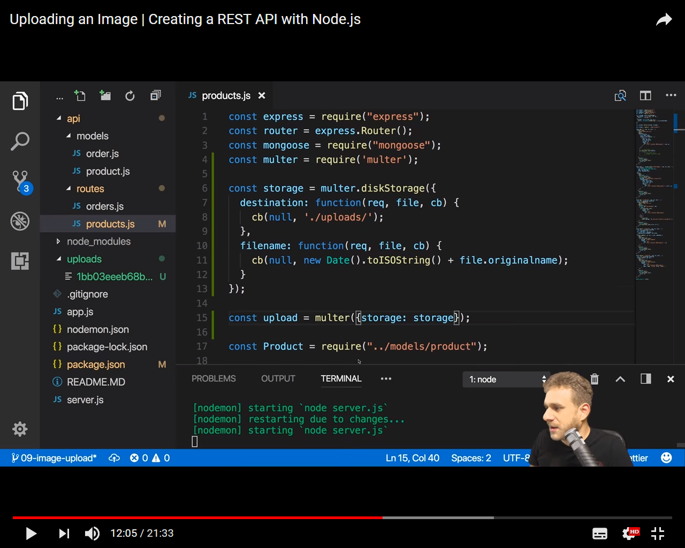

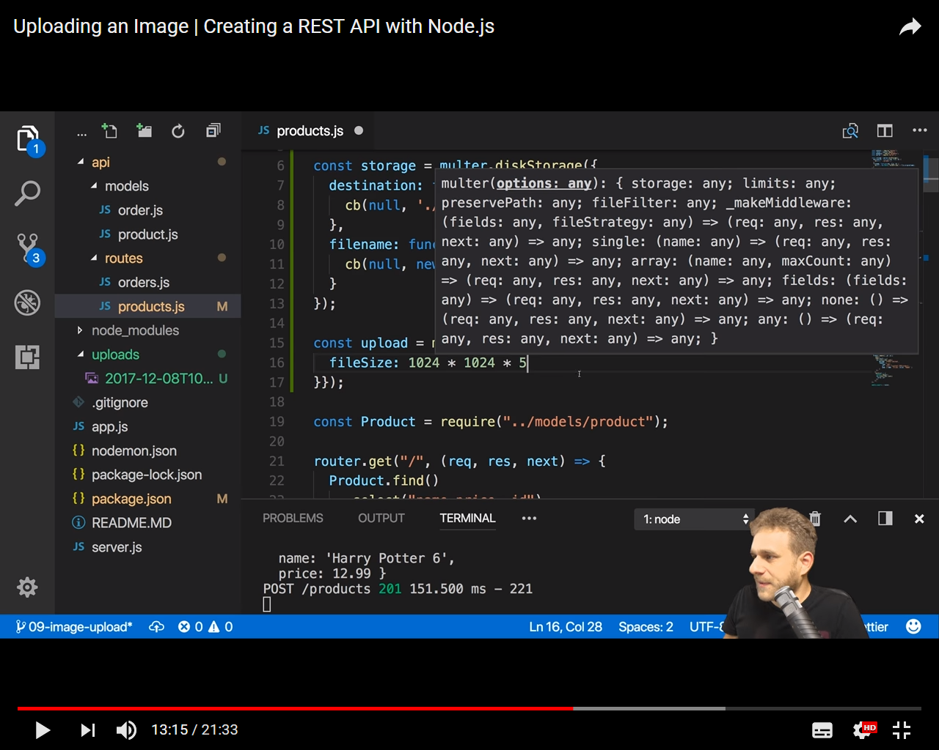

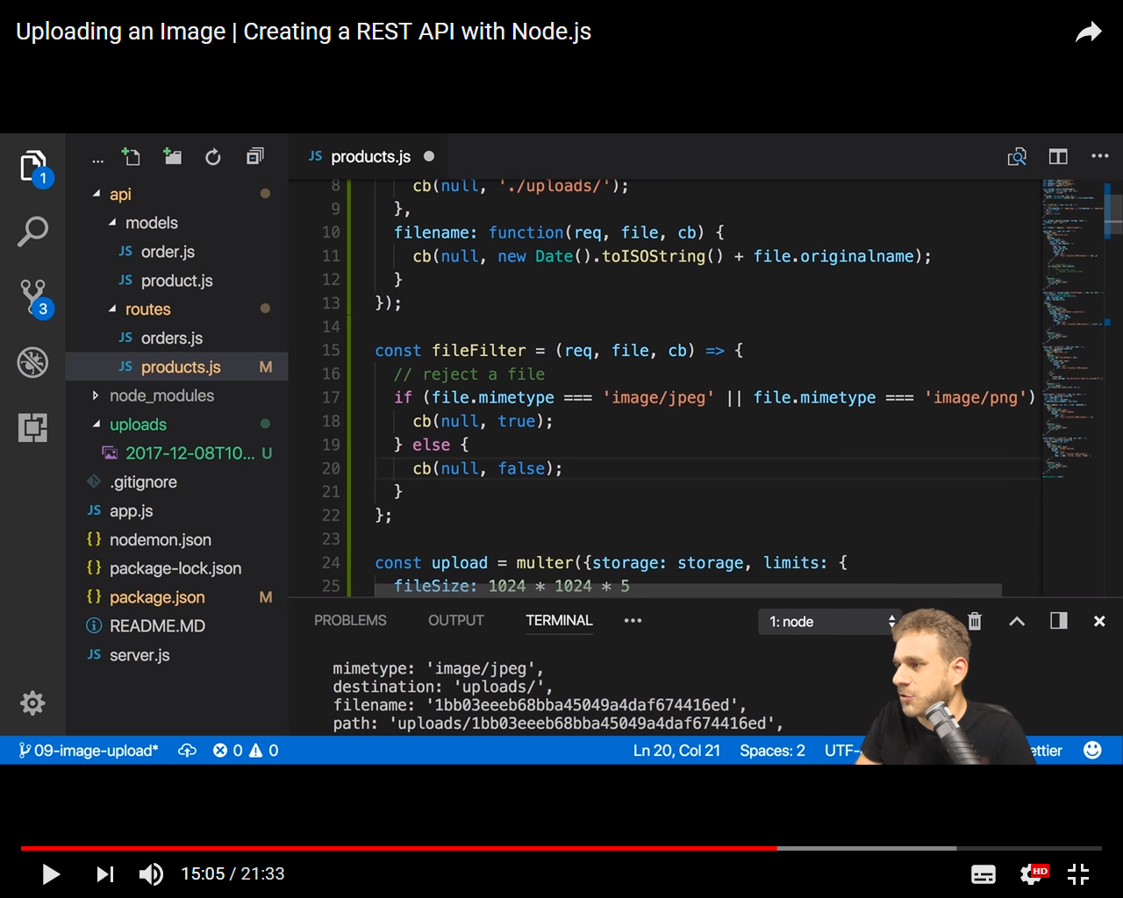

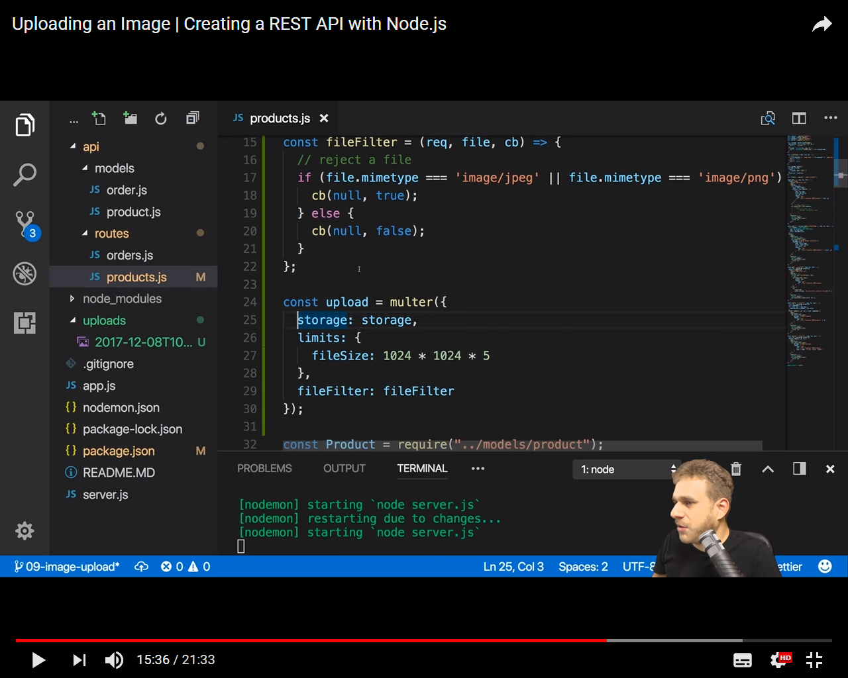

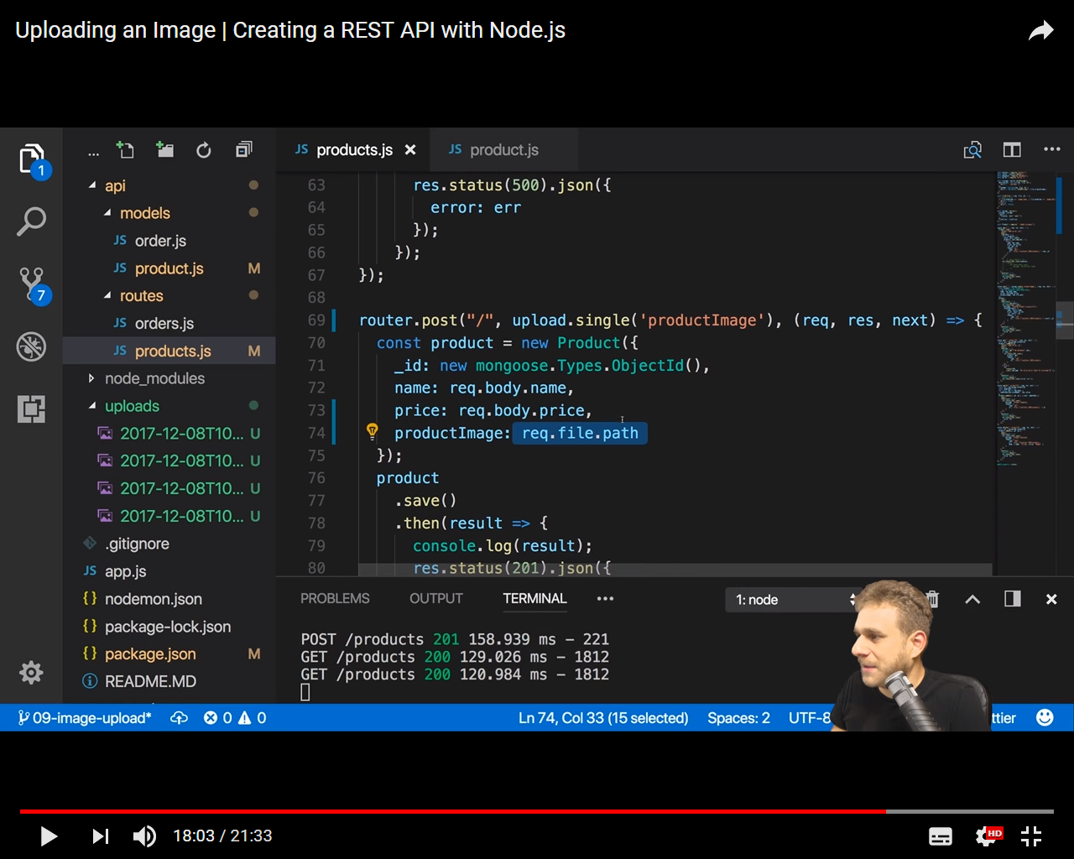

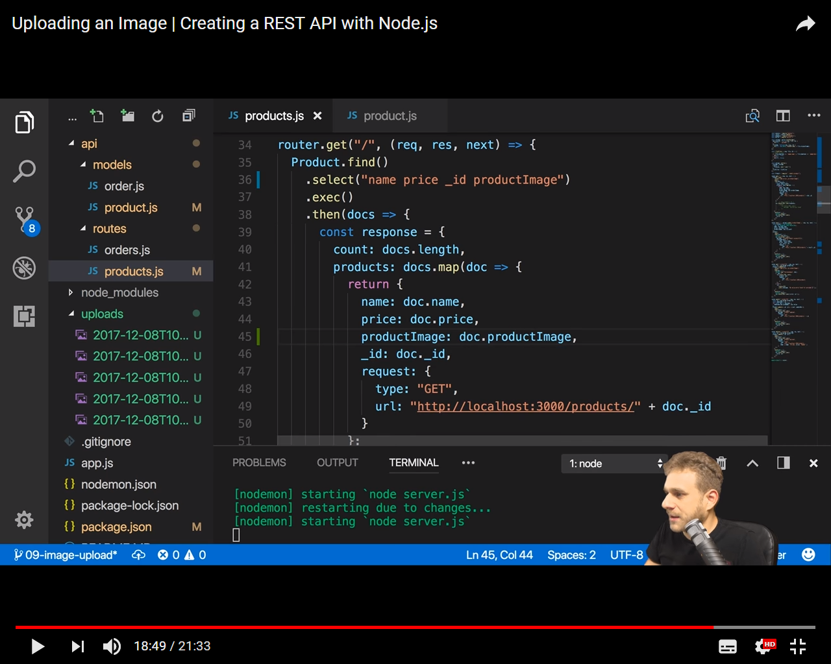

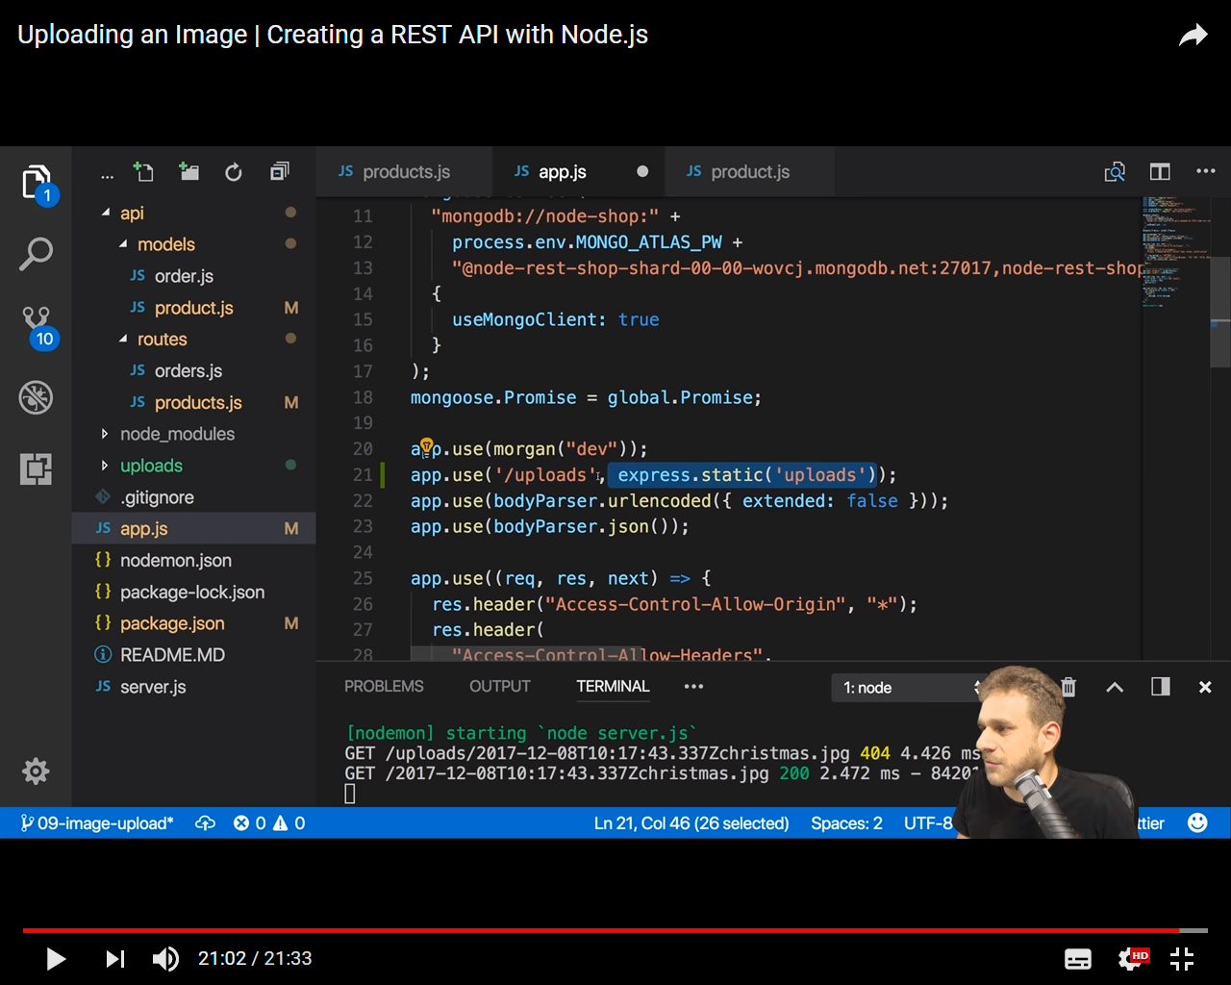

uri: 'mongodb://localhost:27017/mean-angular-2',

secret: crypto,

db: 'mean-angular-2'

echo "# API-MEAN" >> README.md

git init

git add README.md

git commit -m "first commit"

git remote add origin https://github.com/phamtr/API-MEAN.git

git push -u origin master